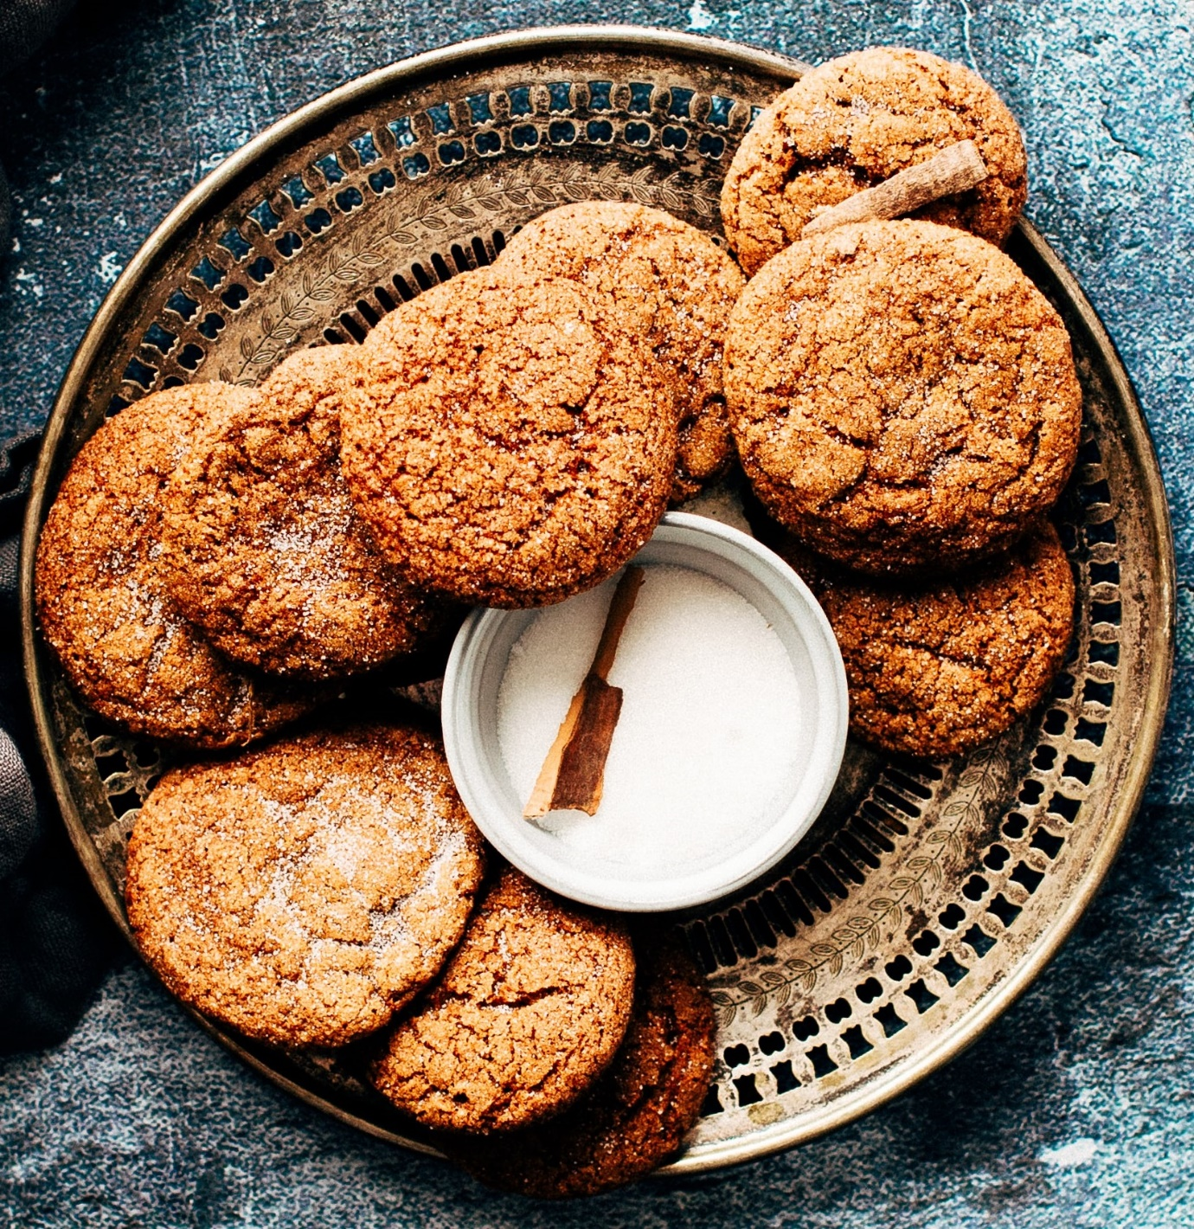

The GingerNut!

The very British biscuit enjoyed by all from as early as 1840! This is a hard ginger flavoured biscuit is best know for being dunked in your morning brew but also for its soothing properties, helping to ease nausea with its ginger infused goodness. Although the original creator of this popular biscuit is not known it has been one of the most popular goodies sold by Huntley & Palmers in Britain all throughout World War II. But the popularity of this crunchy treat does not end there, oh no! In Germany they are known as ‘GingerSnaps’, meaning to ‘seize quickly’ and in Australia the popular vendor Arnots admitting to changing the recipe slightly in many of its factories in order to cater to the variety of tastes across the country.